CORNHOLE TEAMS WANTED!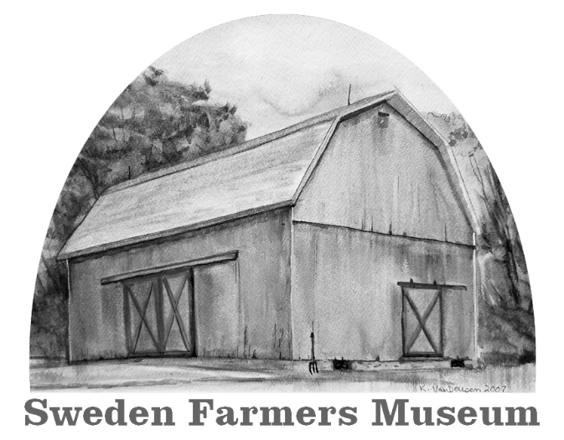
Harvest Festival
Saturday, September 17, 2022
Cornhole Tournament Begins @ 12 Noon
Farmers Museum ~ 4988 Lake Road South, Brockport, NY

CORNHOLE REGISTRATION FORM

Player 1 Player 2

Address

Phone Number Phone Number

PARTICIPANT WAIVER – PLEASE READ AND SIGN
Waiver: I hereby waive all claims against the Town of Sweden, The Sweden Farmer’s Museum, event sponsors, and personnel for any injury I might suffer in this event. I have read this waiver, fully understand it, and freely agree to its terms.
Signature – Player 1
Signature – Player 2
Signature of participants or Parent/Guardian (if participant is under 18 years of age)

